**Chicago crime data analysis EDA**

**Imported Packages:**

Here is the list of packages that are Imported to do my Exploratory Data Analysis. I have used Matplotlib, Seaborn for my visualization of data and Folium for the interactive maps

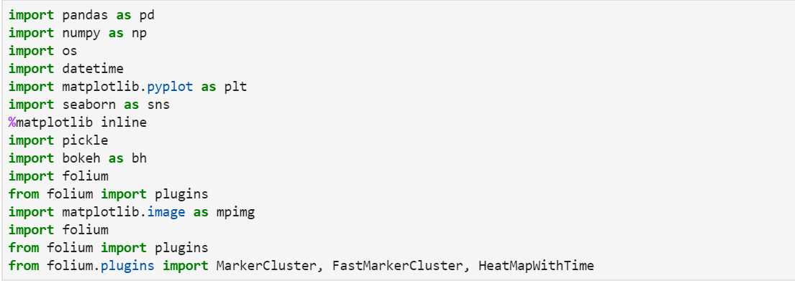

**1.All About Crimes in Chicago**:

By seeing the data, I was very curious to find the topmost crimes in the Chicago. Below figure represents the top 10 crimes in the Chicago. Out of the top 10 crimes, Theft was the most occurring crimes with an count of 1379465.Higher counts of Battery and criminal Damage indicates the presence of physically violent community.

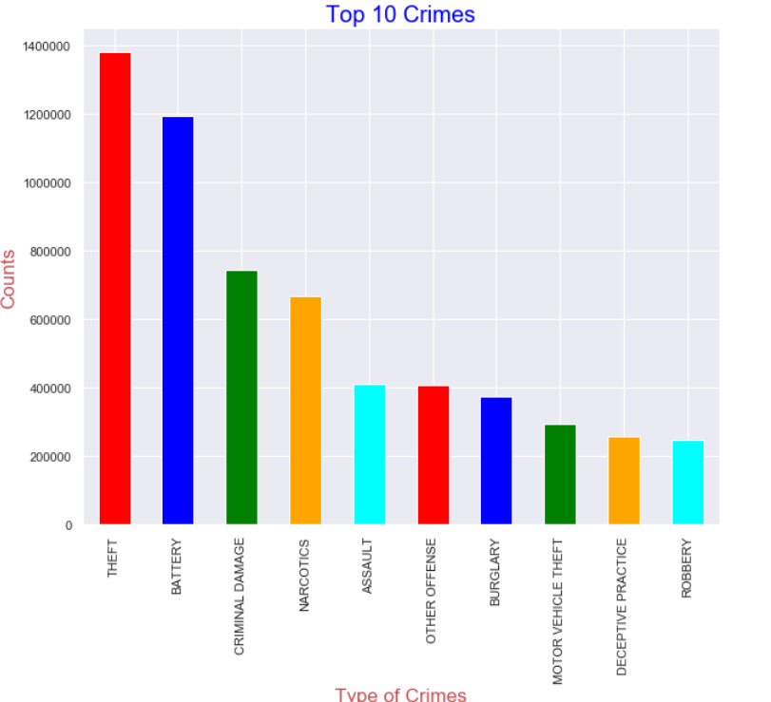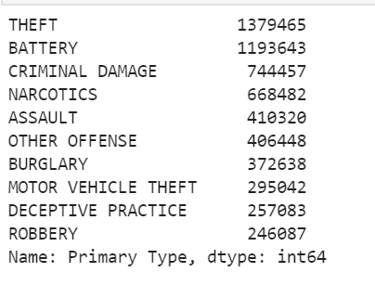

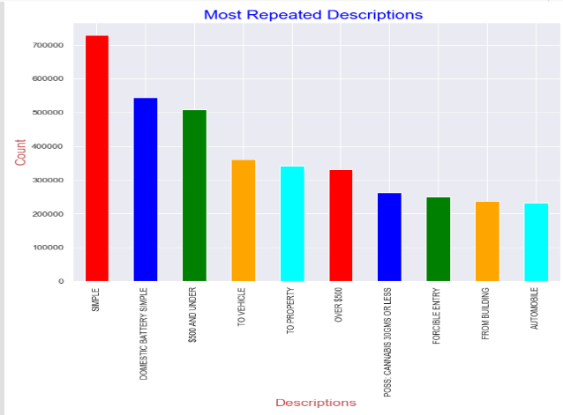The figure represents the Descriptions that are reported along with the crime. Majority of the crimes are reported as Simple and the battery crimes in the domestic reported as simple, some were under 500$ which could be Theft or Robbery or Burglary. Most of the crimes are at street level and at house level  
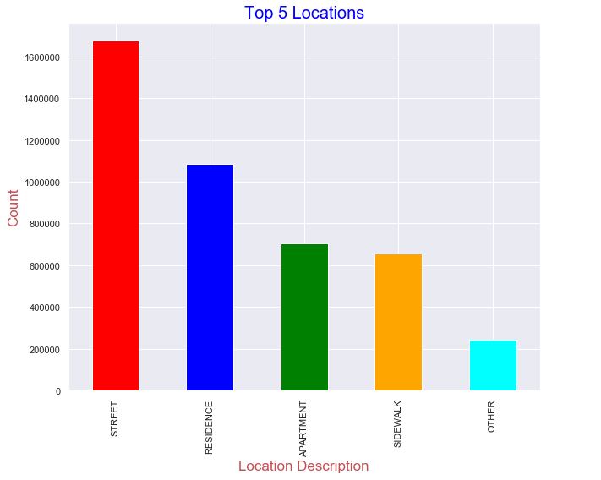

**2.Arrests in city of Chicago:**

73% of the crimes see No Arrests, means only 23 percent of the crimes has been solved from 2001 to present. As we see in the bar chart which represents the crimes with a greater number of arrests, Arrests related to Narcotics are more. 99%of the Narcotics cases we arrested (total narcotics cases were 67000(approximately). As we overall, they are 1379465 theft cases but only 18000 cases are solved, May be police were not taking serious to cases which are involved with the theft and Battery. 87 percent of the crimes are related to Non-Domestic areas.

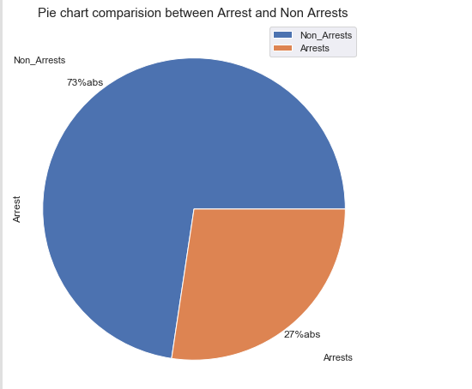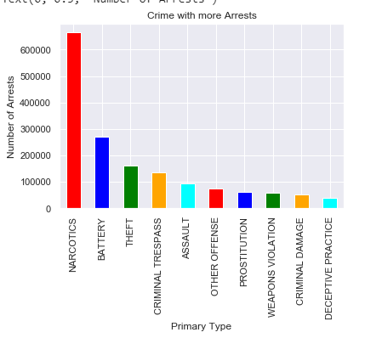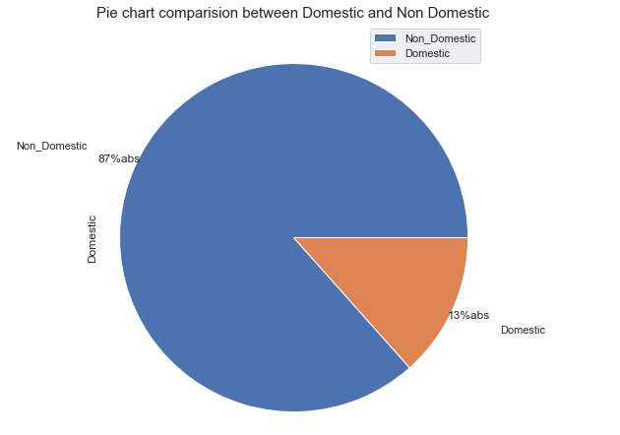

Let’s how the Narcotics arrests distributed across the districts.District 11 is more involved with the crimes.There is down trend of narcotics arrests over the years except some hikes in the year 2013-2014

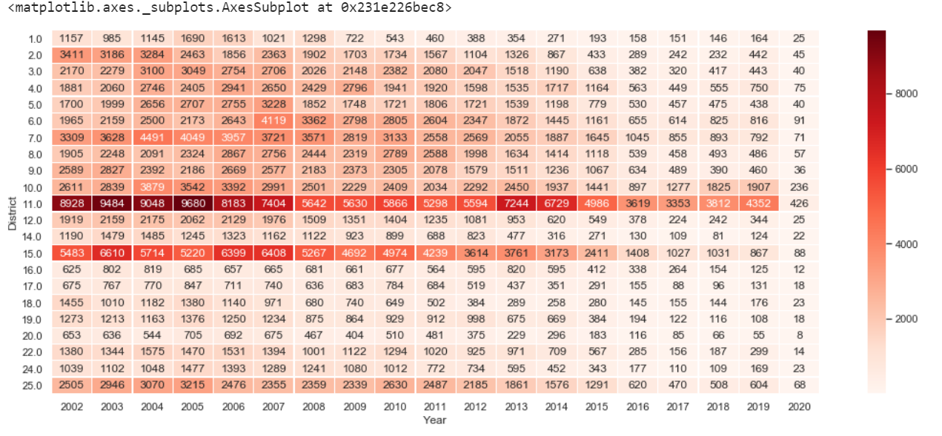

Out of 9421 cases of Homicides,99 percent of the cases are involved with First Degree Murder.56% of homicides are occurring in the streets and followed by Auto, Apartment which contributes 10 percent cases each.

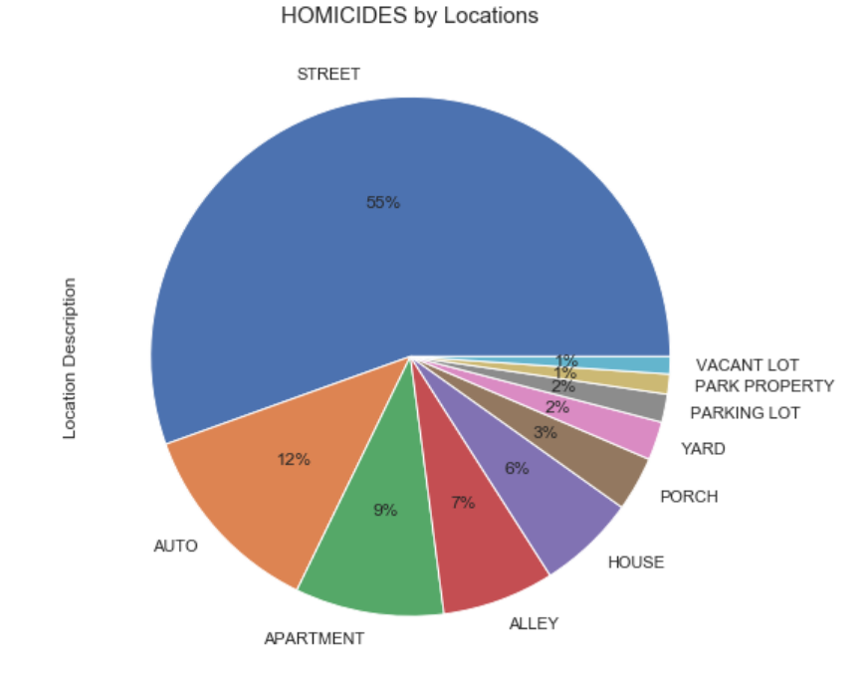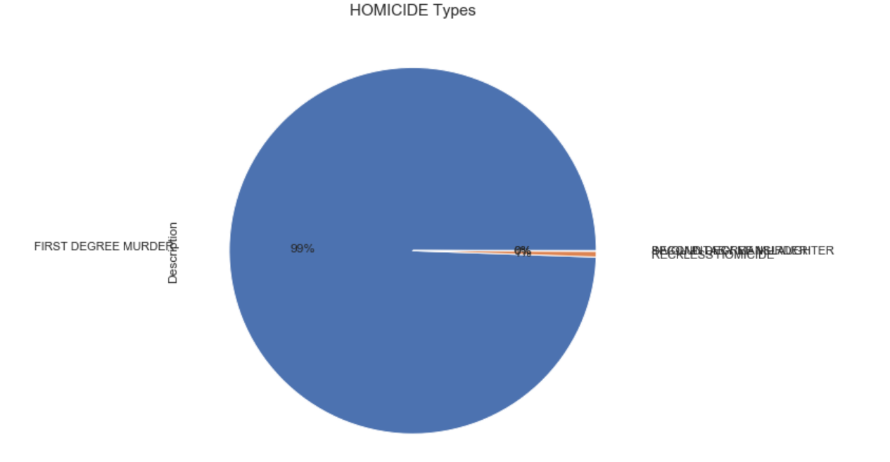

**3. Crime vs Time**:

Here is the Monthly, Hourly, Weekly crime patterns of the crimes in 2019.We see more crime in the summer months, may more people coming out for vacations that might lead to increase in the crimes count. Crime rate increases with the day, needs some rest to crime, less crimes rates between 2 am to 7 pm. coming to weekly part all the days reports the same number of crimes but Thursday and Friday reports slightly greater than remaining days

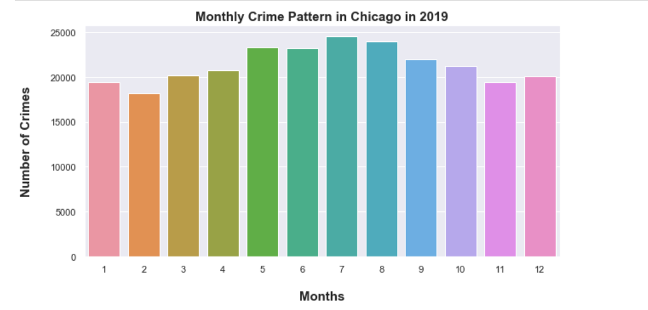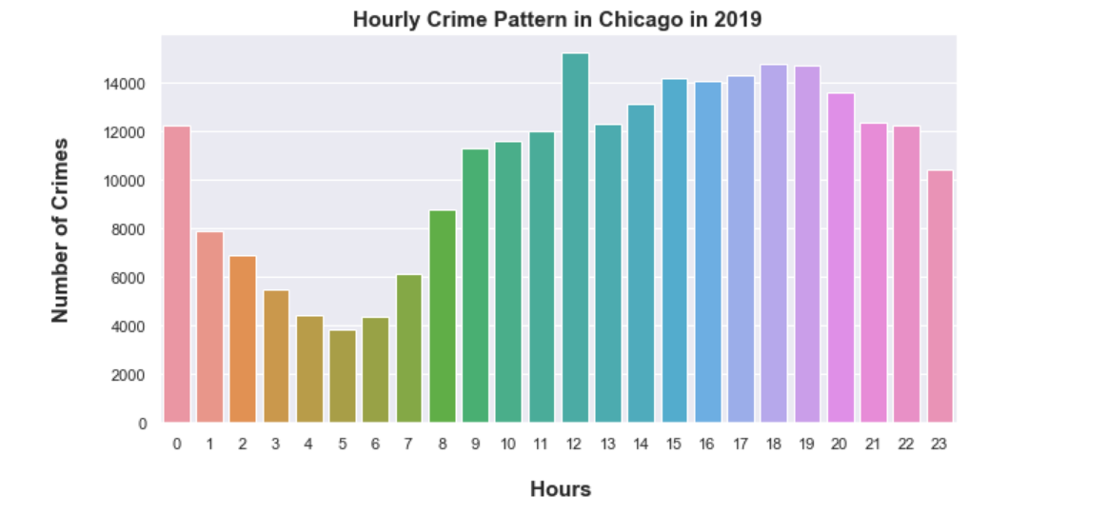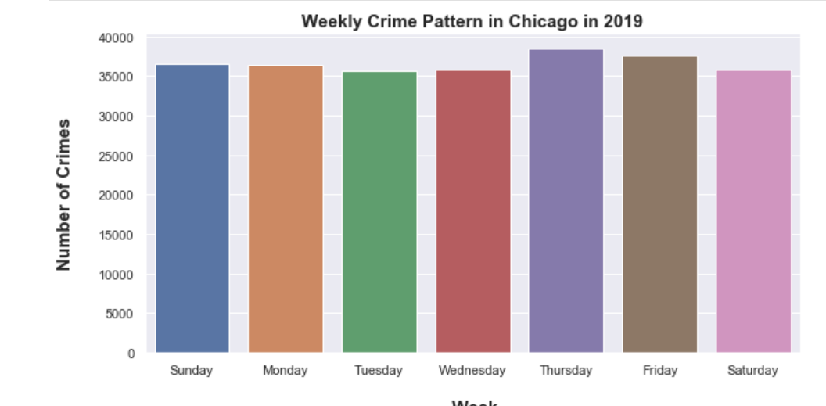

Homicides crime rates vs years

Most of the homicides were happening in the night between 5pm to morning 5am, records very low homicide rate between 7 to 11 am. Districts 11,7,6,15 has more arrests towards homicides compared to remaining districts.

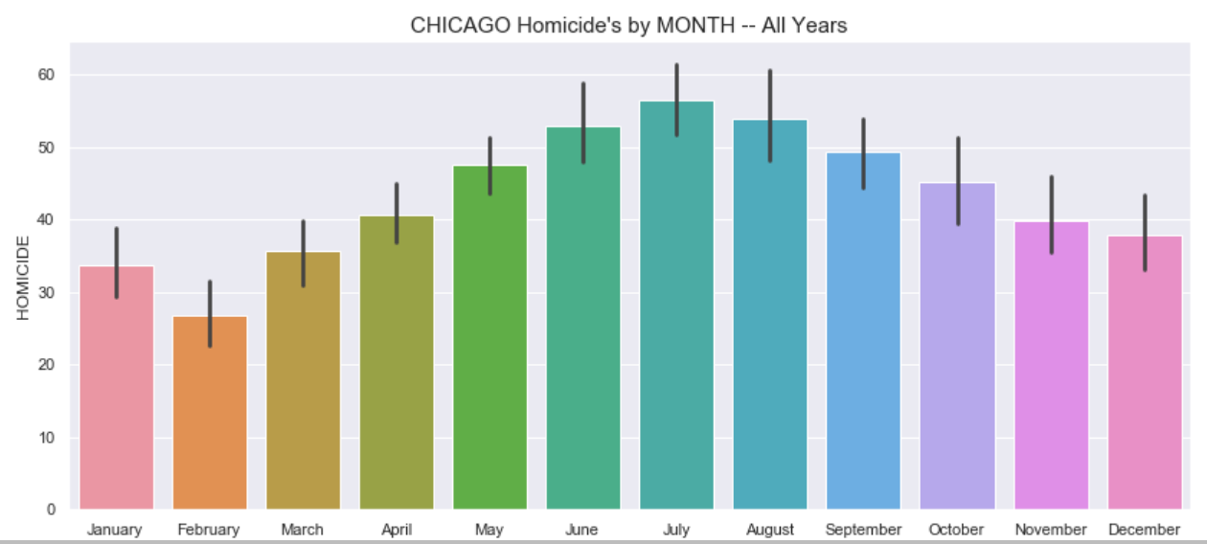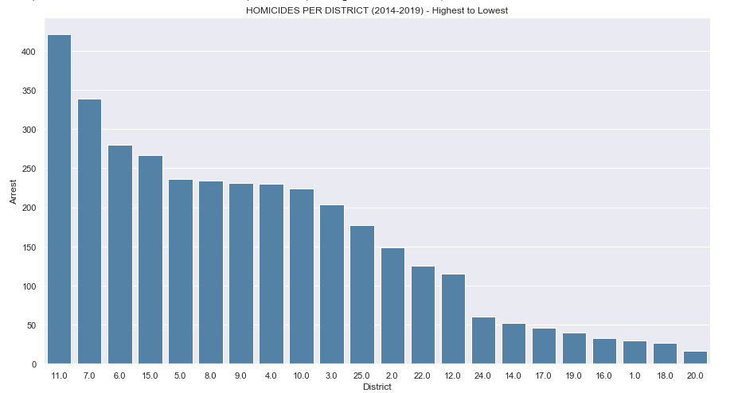

**4.Crimes with Maps**

Below chart shows the arrest count per police district

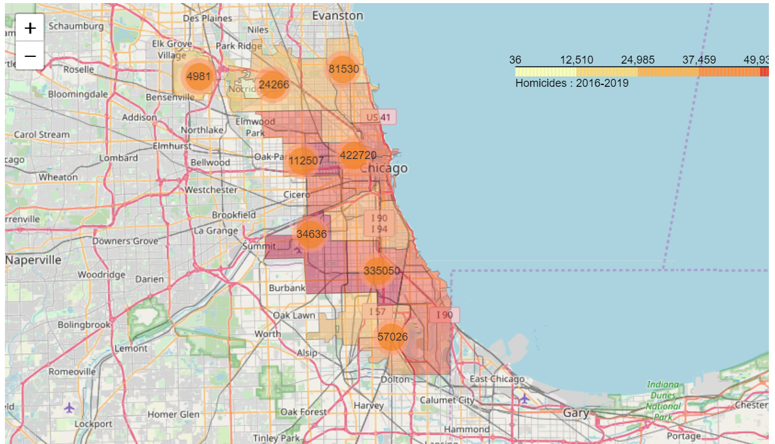

Heat map of all crimes for the year 2019